Nov 2017 newsletter – Twitter & Around the Walls in 80 Tweets
It has been an interesting year for the FOYW Twitter account (www.twitter.com/yorkwallsfriend) which has grown steadily from having under 500 followers last Christmas to over 900 now (see graph). Several of our new friends and volunteers have heard about us via Twitter, so we are making our presence felt among York’s main news & events pages, many of which have a Twitter account e.g. @BBCYork, @theyorkmix, @yorkwhatson (York Press) etc.
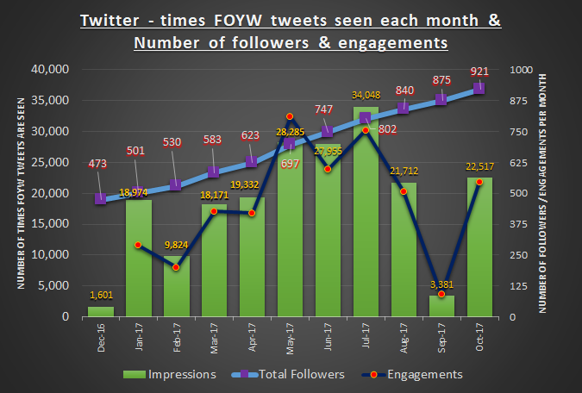
A bit of terminology here before proceeding:
- Impressions are the number of times the tweets were seen on Twitter. @yorkwallsfriend had over 204,000 impressions between Jan and Oct 2017, a 16-fold increase on 2016
- From those, we had 9,500+ profile visits, 4,600+ engagements and 448 new followers. Hence an average of 950 per month actively visited the FOYW Twitter page, 460 per month engaged with us (sent us messages, re-tweeted our messages and pictures, liked our content etc.) and 45 per month actively followed us.
Looking at the 453 tweets made in 2017, the series ‘Around York Walls in 80 tweets’ accounted for many of the most popular messages – 7 of the 10 tweets that gained most engagements were from this series. The pdf (see attached) shows how FOYW sought to interact with other local groups as the virtual tour of the walls unfolded. As well as photos and maps, stories from local websites e.g. York Stories were shared, and there was publicity for events e.g. the Viking exhibition at Yorkshire Museum (as we passed through the gardens) and the Micklegate Run soapbox race (as we covered the western section of the walls). This has hopefully raised the awareness of FOYW with local charities, schools and businesses.
Our top ten tweets follow, based on number of engagements. It seems Monday is the best day of the week for tweeting, and 9am, 2pm and the 8pm – 10pm evening slot best for reaching out. Above all though, make sure tweets include hashtags, links to other Twitter accounts and photos. Don’t forget that you can save your 140 characters, which includes spaces, by using a weblink shortener e.g. bit.ly or tinyurl and/or by having longer passages of text as images.
Martin Hetherington
November 2017
Top tweets of 2017
Engagements | Tweet
94 | 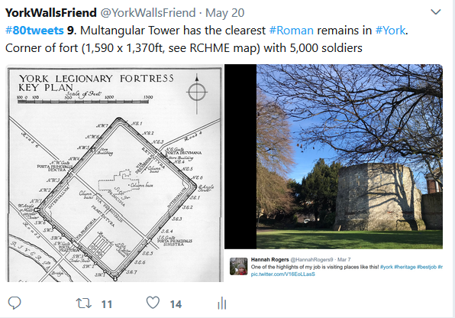
79 | 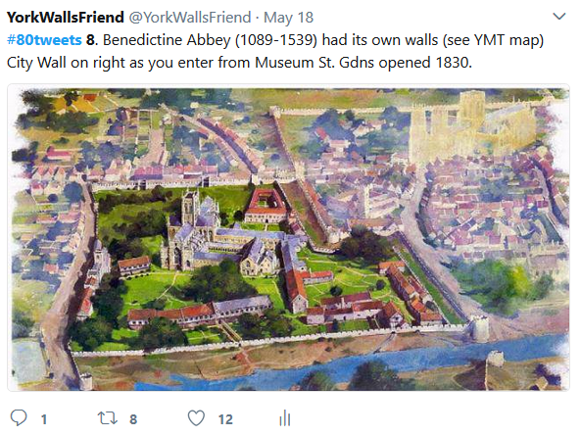
79 | 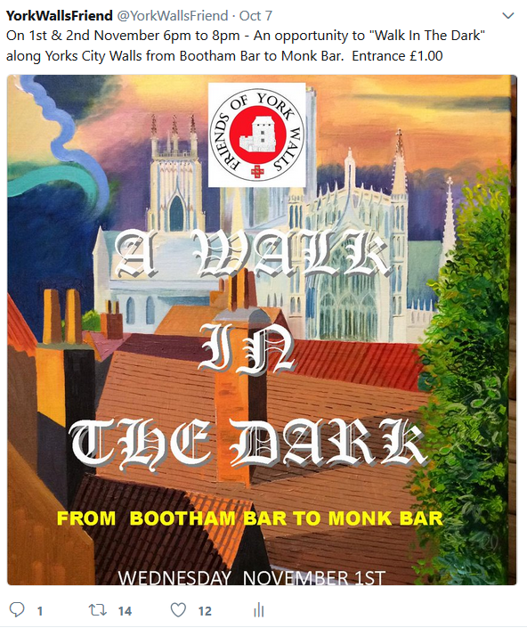
60 | 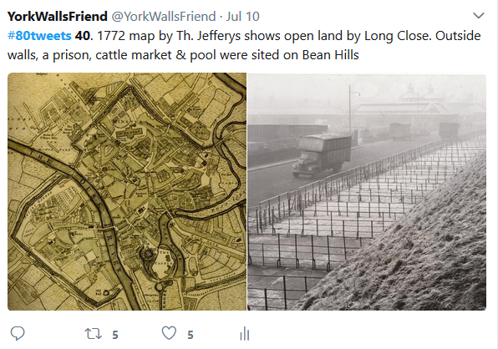
54 | 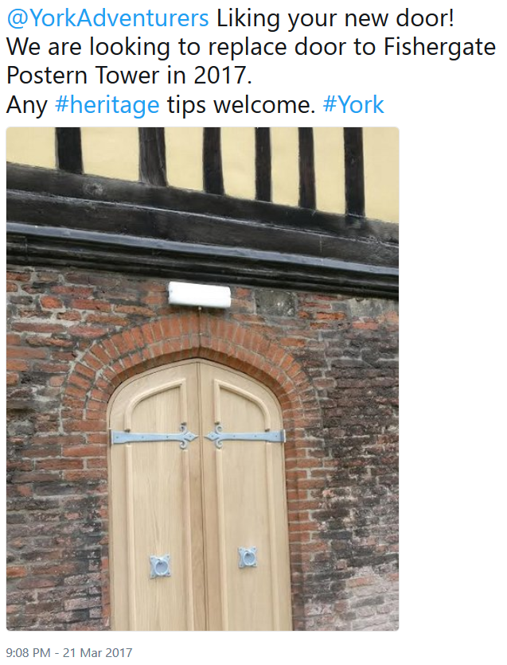
51 | 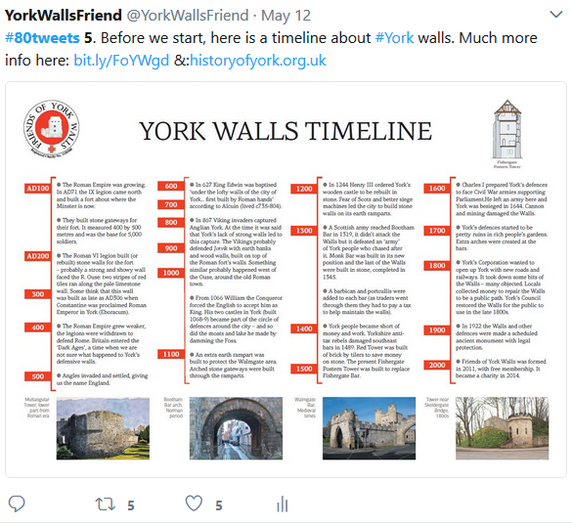
50 | 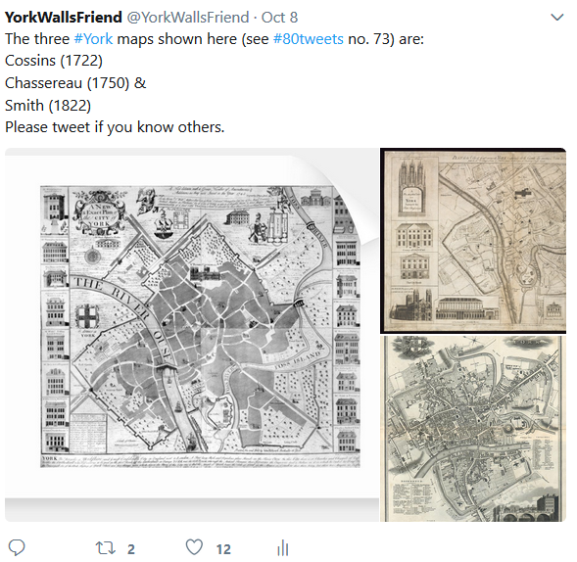
49 | 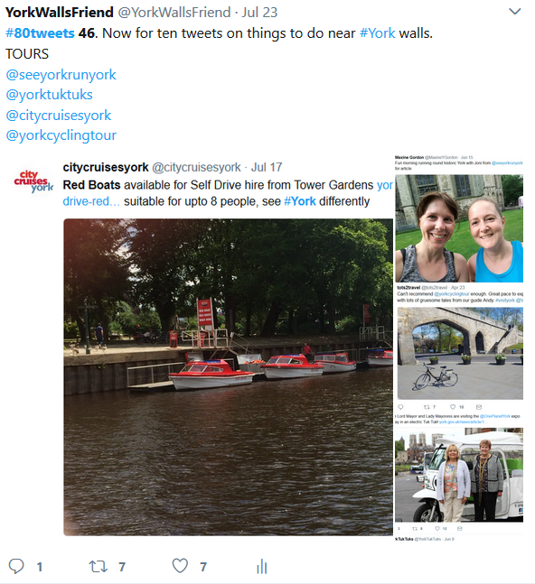  (The woman from @seeyorkrunyork also visited Fishergate Postern Tower and sent us a photo)
46 | 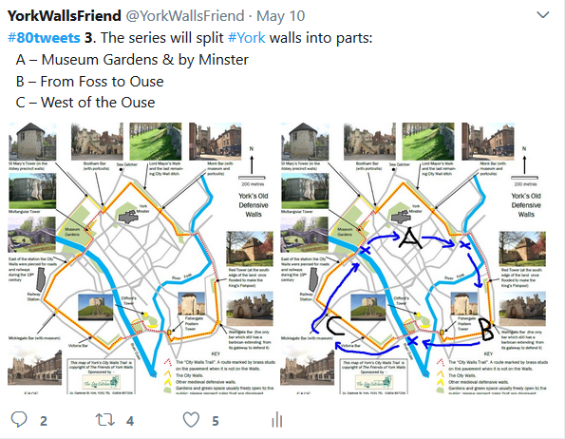
45 | 

